**Statement of Project Completion**

In order to ensure satisfactory delivery of the final information systems project, we ask clients and teams to fill out the following form. This form must be signed and delivered to your faculty advisor before any grade can be issued for the team. The team will see that the signed document is delivered; you can leave it with them. Thank you for the opportunity to serve you this semester.

**A. Delivery of Materials**

We, the AACI, verify that we have received the following materials from the Carnegie Mellon University IS Project Team in satisfactory condition:

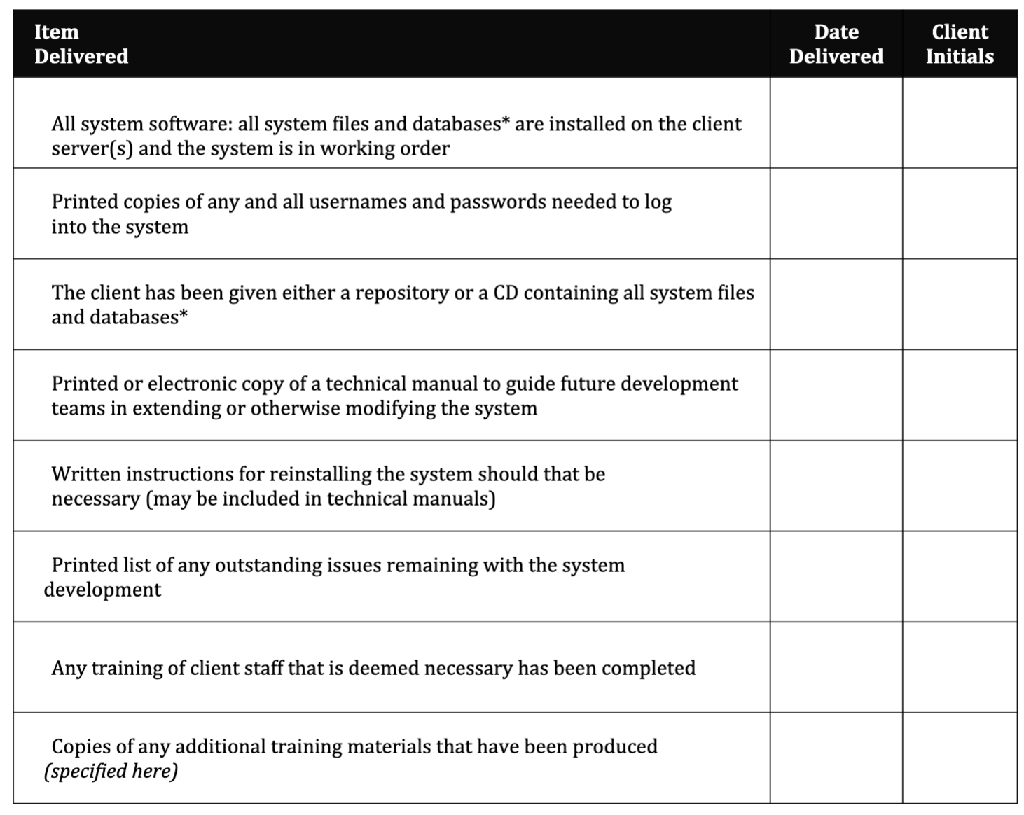

*“ all system files” includes, but not limited to, all source code files, online help files, copies of databases, project or make files, installation files, and any other appropriate files needed for the system to function properly.*

**B. Evidence of System Performance**

In addition, the Project Team has verified that the system was installed and in good working order by demonstrating the following use cases in our presence. We, the client, accept the demonstration of these use cases from the computer/server of our choice as sufficient evidence of a fully-working system.

|  |  |  |
| --- | --- | --- |
| **Test Case**  **Demonstrated** | **Date Shown** | **Client Initials** |
| Application scalable |  |  |
| User testing survey designed and presented |  |  |
| All high fidelity wireframes completed |  |  |
| Client project proposal approved |  |  |
| Application reflected design |  |  |
| Communication with team enabled by channels such as Slack have been meaningful |  |  |
| Demonstrated exceptional effort and engagement throughout project |  |  |

**C. Completion of Project**

All of the items specified above have been delivered and/or demonstrated to the client’s

satisfaction. The materials have been provided to the client on a pro bono basis; no fees

or monies have been paid or will be paid to either the team or the University for this

Project. The client is aware of and accepts the fact that any materials or intellectual

property furnished pursuant to this project is furnished on an “as is” basis. The Project

Team and Carnegie Mellon University make no warranties of any kind, either expressed

or implied, as to any matter, including, but not limited to, warranty of fitness for purpose,

merchantability, exclusivity or results obtained from use; nor shall either party hereto be

liable to the other for indirect, special, or consequential damages, such as loss of profits or

inability to use.

____________________________ _____________________________

Client Representative (signed) Team Representative (signed)

____________________________ _____________________________

Client Representative (printed) Team Representative (printed)

____________________________ _____________________________

Date Received Date Delivered

*One signed copy of this agreement must be returned to the faculty advisor before any team*

*grade can be assigned. It is strongly suggested that an additional signed copy be left with*

*the client for their records*